Proof of concept (POC)

Document Title: Import Web Page Content as PDF Feature Documentation

1**. Introduction:**  
The "Import Web Page Content as PDF" feature is a functionality integrated into the PDF Converter Angular application, allowing users to effortlessly convert content from web pages into PDF format. This documentation serves as a comprehensive guide, providing detailed instructions and guidelines on how to utilize this feature effectively.

With this feature, users can input the URL of a web page containing the desired content they wish to convert into a PDF. The application then processes this input and generates a PDF document that accurately captures the content of the specified web page. This functionality streamlines the process of saving web content for offline viewing or sharing, enhancing user convenience and productivity.

Throughout this document, users will find step-by-step instructions for setting up the PDF Converter Angular application to enable the "Import Web Page Content as PDF" feature. Additionally, it provides a user guide detailing how to use the feature effectively, including entering the URL, initiating PDF generation, and handling confirmation or error messages.

Furthermore, this documentation includes information on conducting a live demonstration of the feature, showcasing its functionality to team members or stakeholders. It emphasizes the importance of effectively communicating the capabilities and benefits of the feature during the demonstration, as well as addressing any potential challenges encountered during development.

In summary, this document serves as a comprehensive resource for users of the PDF Converter Angular application, providing all the necessary information to successfully utilize the "Import Web Page Content as PDF" feature.

**2**. **Setup Process:**

The setup process for enabling the "Import Web Page Content as PDF" feature in the PDF Converter Angular application involves the following steps:

**2.1 Angular Setup:**

* Ensure Node.js and npm are installed on your system.
* Install Angular CLI globally by running **npm install -g @angular/cli**.
* Create a new Angular project by executing **ng new pdf-converter**.
* Navigate to the project directory using **cd pdf-converter**.

**2.2 Library/API Configuration:**

* Obtain an API key from PDF.co, the service used for PDF conversion.
* Replace the **API_KEY** variable in the **Pdf Generation Service** file with your obtained API key.

**2.4 Running the Application:**

* Launch the Angular development server by running **ng serve**
* Access the application in your web browser at **http://localhost:4200/**.

By following these setup instructions, you'll ensure that the PDF Converter Angular application is properly configured to utilize the "Import Web Page Content as PDF" feature.

Certainly, let's elaborate on each step of the user guide for utilizing the "Import Web Page Content as PDF" feature:

**3. User Guide:**

**3.1 Entering URL:**

* In the application interface, you'll notice an input field provided for entering the URL.
* Simply click inside the input field and type or paste the URL of the web page you wish to convert into a PDF.
* Ensure that the URL entered is valid and accessible.

**3.2 Generating PDF:**

* After entering the URL, direct your attention to the "Generate PDF" button located near the input field.
* Click on the "Generate PDF" button to initiate the conversion process.
* Once clicked, the system will start converting the content of the provided web page into a PDF format.

**3.3 Confirmation/Error Handling:**

* **Confirmation:** If the PDF generation process completes successfully without any issues, a confirmation dialog will appear on the screen.
  + This dialog will typically contain a message indicating that the PDF has been generated successfully.
  + You may also receive a notification confirming the completion of the process.
* **Error Handling:** In case an error occurs during the PDF generation process, the system will display an error message.
  + This message will inform you about the nature of the error encountered.
  + Common errors may include network issues, invalid URLs, or problems with the PDF conversion API.

By following these simple steps outlined in the user guide, users can effectively utilize the "Import Web Page Content as PDF" feature within the PDF Converter Angular application.

**4. Feature Showcase:** In this part of the demonstration, I will actually showcase the core functionality of the feature, which is the ability to accurately convert different types of web pages into PDF documents. You can select a variety of web pages with different layouts, content types (text, images, tables, etc.), and structures to demonstrate how the feature handles each of them. By visually presenting the conversion process and the resulting PDFs,

highlight the accuracy and effectiveness of the feature in capturing web page content.

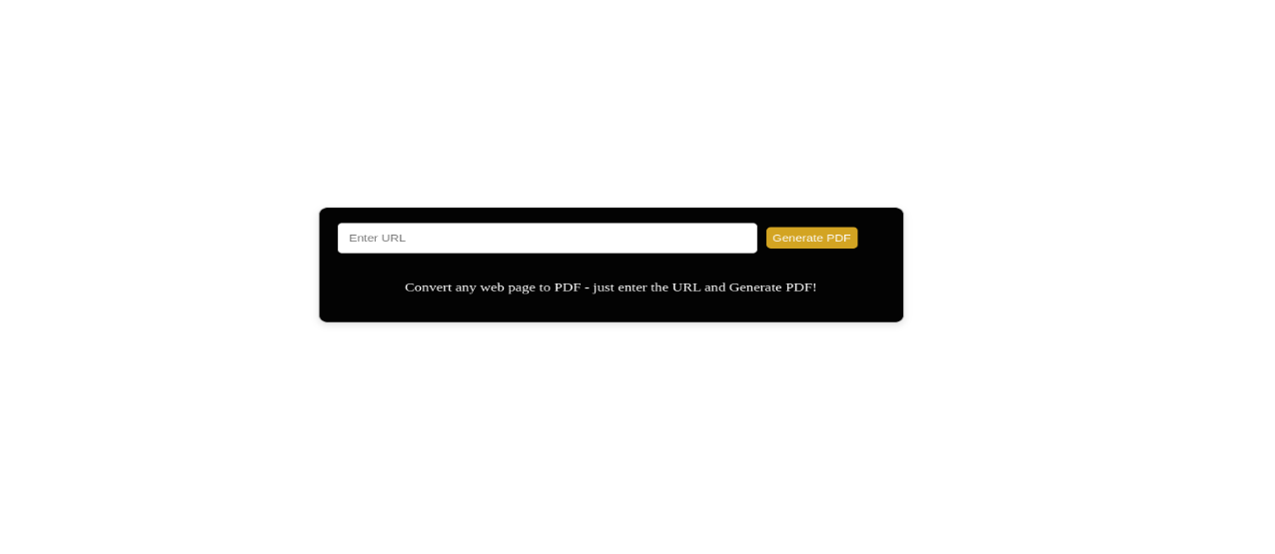

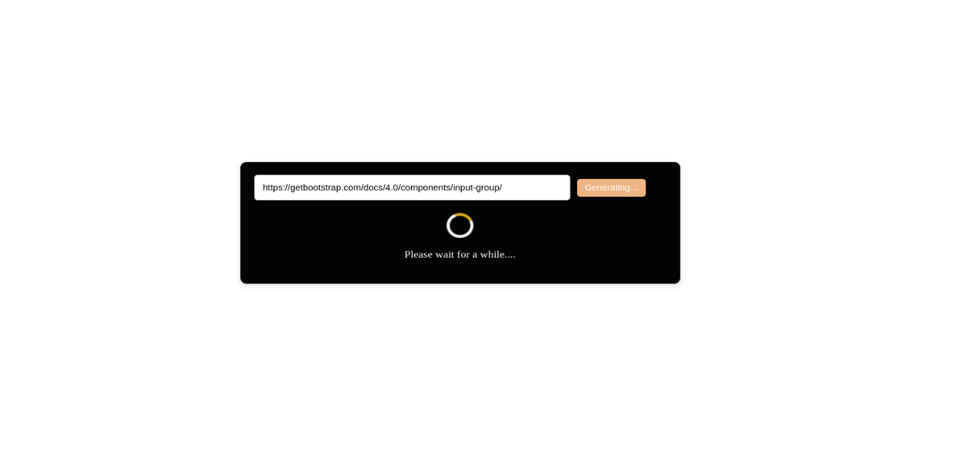

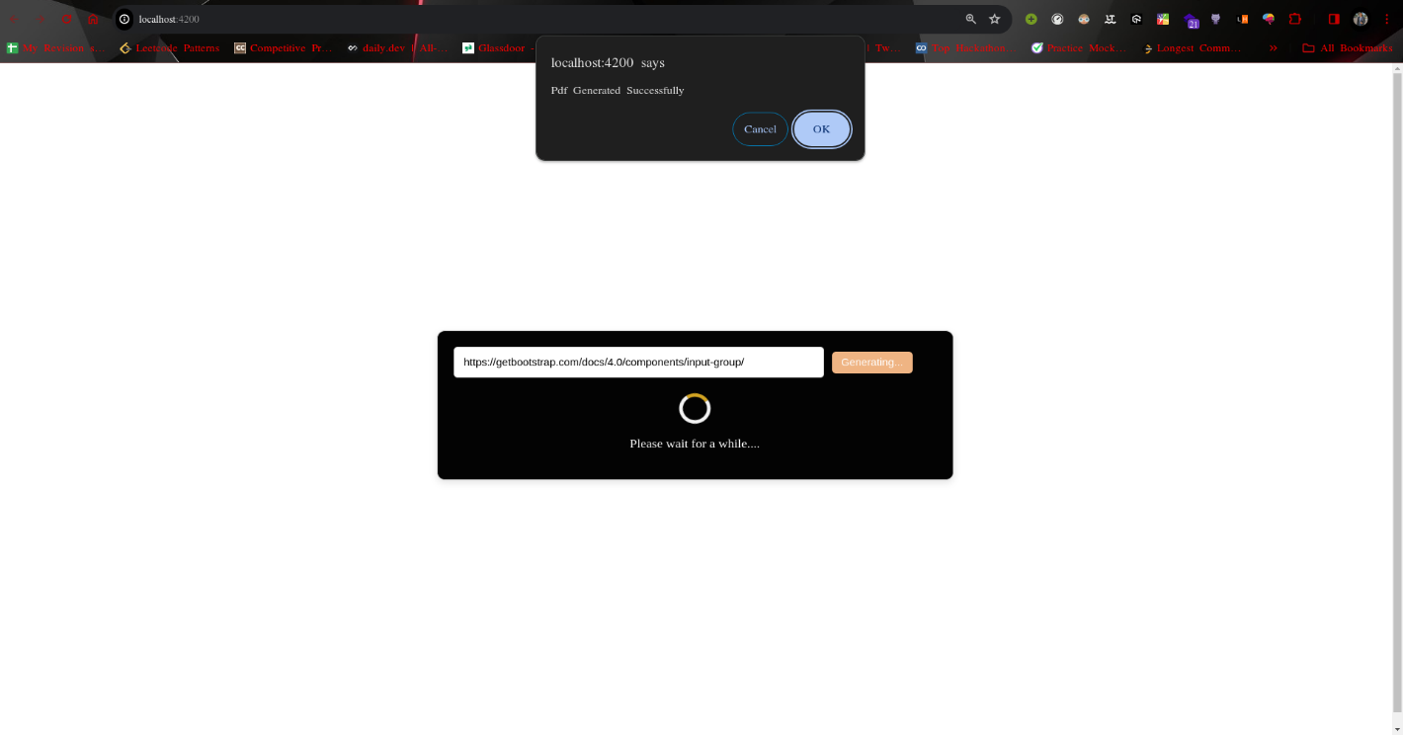

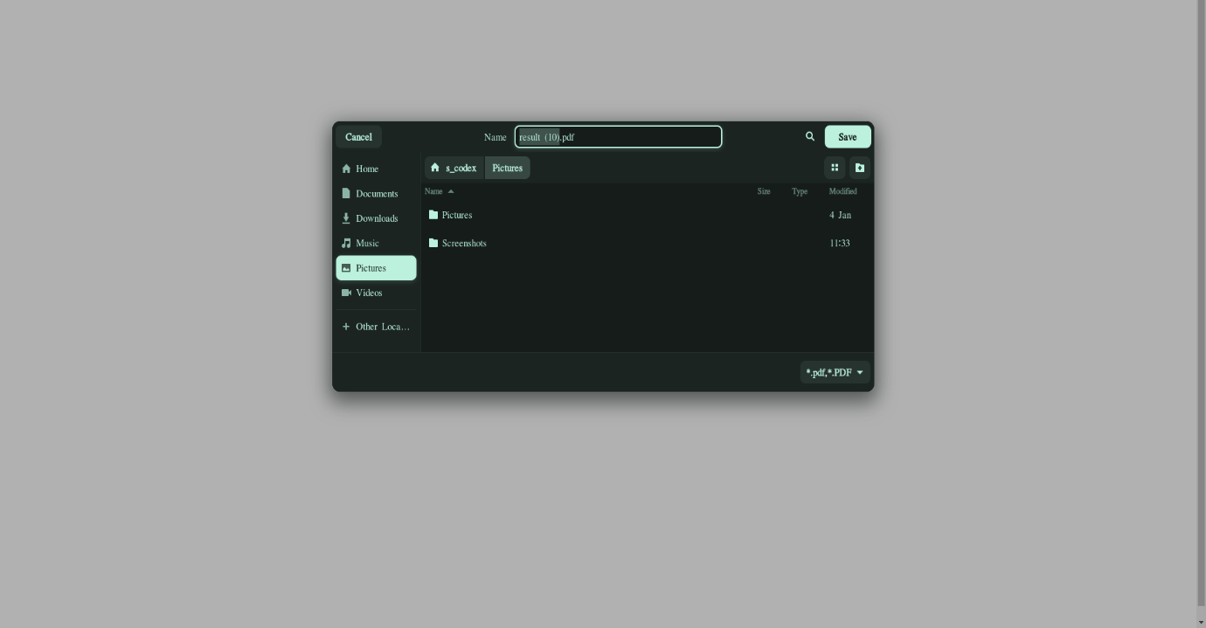

**4.1 Development Challenges:** **1. Integration with External API:**

* **Challenge:** Integrating the application with an external API (PDF.co) posed a challenge due to the need to adhere to API documentation, handle authentication, and ensure proper error handling.
* **Solution:** Thoroughly studied the API documentation provided by PDF.co to understand endpoints, request parameters, and authentication mechanisms. Implemented proper error handling strategies to gracefully manage API responses, such as handling network errors and server-side errors. Utilized Angular Http Client module to send HTTP requests to the API endpoints and process responses accordingly.

**4.2 Live Demonstration:** During the live demonstration, I will present the feature in action to the team members. This includes executing the feature within the application environment and guiding the team through its usage. As you demonstrate the feature, be prepared to address any questions, concerns, or feedback raised by the team members. This interactive session allows for clarification of doubts, validation of functionality, and discussion of potential improvements or enhancements to the feature.

In summary, the Demonstration section is an integral part of presenting the "Import Web Page Content as PDF" feature to the team. It involves showcasing the feature's functionality, discussing development challenges and their resolutions, and conducting a live demonstration to engage the team and gather feedback.  
Please Refer to Github Repo for live Demo video-  
- https://github.com/S-dev-coder/ProjectTask-2